7.0 Workspace Base
The workspace is the most important part of Lexcen. It’s where a user will design, view and compare a Solution. For context we will setup through a prototype, but this story is related to building the base of the workspace. Future stories will add functionality incrementally.
The workspace itself is made up of a number of components
- Solution Title Bar- To be placed immediately under the Application header and runs horizontally across 100% of the screen width. It’s locked and displays primary info regarding the solution being worked on.
- Tabs – Each solution is segmented into logical parts, we will use tabs to navigate these sub sections. Each tab will load/input data for the solution and have specific validation rules for guiding the users.
- Body – This is where all the action will happen and will vary based on which tab has been selected and the visualisation mode (more on that later)
7.1 UI Wireframes
Solution Title Bar
Tabs
We would like to use the following Material U/I menu component with two changes
(1) We would like to display both an icon and a text underneath the icon
(2) Add the ability to display warnings & errors – these would be use to validation.
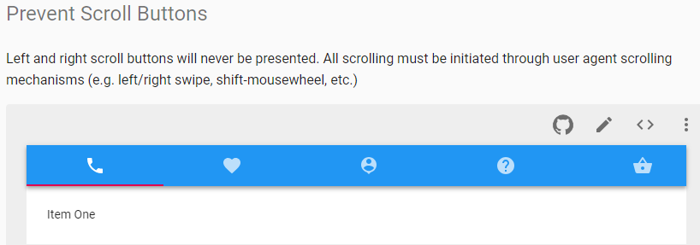
7.2 User Story Flow Chart (TBA)

7.3 Screen Logic
Our thinking is that all Soultion designs or reviews will open in a new tab and that page/tab once opened would be restricted to that Solution alone. In essence one workspace = one Solution (ID)
On workspace page load
(1) We can {open for discussion} retrieve the entire JSON for the Solution/Version and work with that entirely on the client.
On exiting or moving between tabs
(1) Run a validation routine for the relevant tab or all tabs if exiting and based on the results returned we would warn the user by
- An amber “!“ mark on the relevant tab
- Display alerts when a user hovers over the Tab.
(2) Save any changes made to data for that solution the display a popup modal to
If the page has been idel for 600 seconds
(1) Need to display a modal requesting the user to refresh the page (reload current solution version)
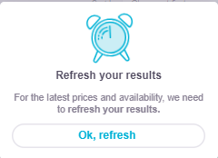
Text to be changed to – We noticed that this solution has not been worked on for a while, best to to refresh!
7.4 data
SoultionMaster.csv

7.4 Notes
- Access Control – its assumed that b/e code would manage this and only the solution that the user is authorized to access will be returned by these API’s.
- Functionality of each Tab Will be covered separately. In this Phase we are covering Call flow only.

Acceptance criteria
Verify non functional requirements are met including:
- Browser support: Chrome, IE, Explorer, Safari and Firefox
- Desktop, iPAD and Android tablets should be supported
- Screen resolutions of (TBD) result in a usable interface and the modal pop up is displayed correctly
- The interface does not present any significant lag after clicking the “Add” icon before displaying the modal pop up
The following software design guidelines are met:
- The list of display actions in the modal popup may be extended by changes in the backend without requiring a change of client side code
- Client should leverage capability of AWS AppSync SDK
- The client – backend exchange is restrained to a singular GraphQL query noting responses maybe cached for reuse within the client side code and maybe pre-populated at the creation of the call flow (for developer to decide)
The following regression testing items are noted, ensuring no bugs or undesired change in behaviour are introduced:
- None

